SOUTHERN CALIFORNIA INVITATIONAL COMBINE (SCIC)
Palomar Racing Pigeon Club, San Diego Racing Pigeon Club,
Valley Invitational Racing Pigeon Club, Y2K Racing Pigeon Club
MEETING MINUTES – January 13, 2021

The meeting was called to order by Luis Gomez, President at 11:00 am. Delegates were present from Palomar Racing Pigeon Club, San Diego Racing Pigeon Club, Valley Invitational Racing Pigeon Club and Y2K Racing Pigeon Club (PAL, SD, VIP, Y2K). Palm Springs Club was not Present.

MINUTES FROM PREVIOUS MEETING
Minutes from January 6, 2019 were read in summary. PAL made a motion to accept minutes, Y2K seconded. Accepted.
PROPOSALS FOR MEMBERSHIP
The following members were voted into Combine for each club noted:
SD
1. Aldvin Malonzo 8169 Brookhaven Rd., San Diego92114
858-345-0642 aldvin_m@yahoo.com
2. Alex Ortega 5839 Dehesa Rd., El Cajon, Ca. 92019
619-933-2958 onecrewdoesitall@gmail.com
3. Omar Quiononez 10767 Jamacha Blvd.#59, Spring Valley, Ca.
619-991-7814 omarqsandiego@yahoo.com
4. Mark Rafo 773 Sandalwood Dr., El Cajon, Ca. 92021
619-415-1319 markrafo88@gmail.com
5. Joseph Rivera 1509 Marla Ave. Spring Valley, Ca. 91977
619-419-6442 email@awardmaster.net
6. Jr.members: Amed Tawfique, Darrin Tawfique, Hani Tawfique,
Mohammad Tawfique, Sura Tawfique. All same info as Alan
Tawfique.
VIP
1. Shirley Aikens 26955 Garbani Rd., Menifee 92584
951-758-2915
2. Margaret Howell 26955 Garbani Rd., Menifee 92584
*Flying together at same location as Bill Blankenship under Family Membership
Y2K
1. Tony Martinez Perris, CA 92570
951-581-2071 tonygrey7@icloud.com
2. Kevin Johnson 171 W. Westmont, Hemet, CA 92543
951-390-1714 kpj2525@yahoo.com
3. Humberto (Tito) Franco 2880 Landau Blvd, Cathedral City, CA 92234
760-610-9214 h_franco83@hotmail.com
4. Victor Castaneda 15965 Via Vista, Desert Hot Springs, CA 92240
760-333-8810 whitedoverealeseps@gmail.com
*Tito Franco and Victor Castaneda were both previously voted into the Palm Springs Club. Limited flyers in their area has resulted in their joining Y2K.

Welcome all new Flyers.
FINANCIAL REPORT
Carl Cardarelli, SCIC Treasurer, reported balance to be $360.00.

UNFINISHED BUSINESS
None

NEW BUSINESS
FLYERS: SD – 20, PAL 9-10, VIP – 5, Y2K 10-11 Approximately 46 Total

DRIVER
Doug Shenert, Teacher from Fallbrook, will be our driver. Doug has experience in hauling horse trailers. Accepting $1 per mile, paying for fuel himself. Any purchase over $2.75 will be paid by SCIC. Doug cannot take birds the second race weekend. Delegates agreed to keep schedule in tact by having Caldwell of the San Diego club haul trailer Saturday for Sunday race.
Conveyor Driver Checklist/Insurance – Steve Miner will go over checklist with driver.

PAL AND SD TRAILERS
Palomar Trailer has been serviced. San Diego trailer will need thorough cleaning and disinfecting the water trays. WD40 doors. Trailer will need to be repainted at a later date. Steve Miner will hire someone to clean trailer possibly at $100 week during season, possibly a bit more the first time. Steve will determine cost.
DUES
SCIC Combine Adult Dues are $20 and due presently. As noted below from our By Laws, Junior membership fees have not been established. Shipping is indicated as $1. Assuming $1 per bird. Junior Dues will need to be established for Combine.
2.00 MEMBERSHIP DUES: Annual dues for members were determined as $20 at the annual meeting in December, by a majority vote of the active members present. $300 shipping fee will also be due by those flying at the season. Members who live in an environment which does not allow them to raise a full team, may ship 15 birds at $200 for the season. This is not for the flyers who can raise 20-40 or more birds who choose to cut their team. No more than 15 birds will be shipped for these flyers to any race in the season. Half can be paid first race, second half due at Olancha Race. Juniors are $1 shipping. This is in addition to the adult team for the family. Race Secretary is responsible for doing GPS at each loft and is required to monitor both 15 bird team lofts and Junior membership. The Southern California Invitational Combine dues, as well as those associated with other organizations, which the Southern California Invitational Combine is affiliated, are due, and payable on the date provided at the annual meeting. Members are not allowed to race or purchase bands until dues have been paid. (Some clubs also include specific work parties or events as part of the membership "Obligation," and charge additional fees if a member does not participate).
2.03 Junior members are those members who have not reached their 18th birthday. He/she shall pay the prescribed AU dues for juniors and whatever portion of the Southern California Combine Invitational dues that the regular members decide.

RACE SCHEDULE
Race Schedule is listed below. Steve Miner indicated questionable releases beyond Bishop due to weather, etc. will be determined by Clay McBeth.
NOTE: First Redding will not be flown. Week will be reserved for possible changes.
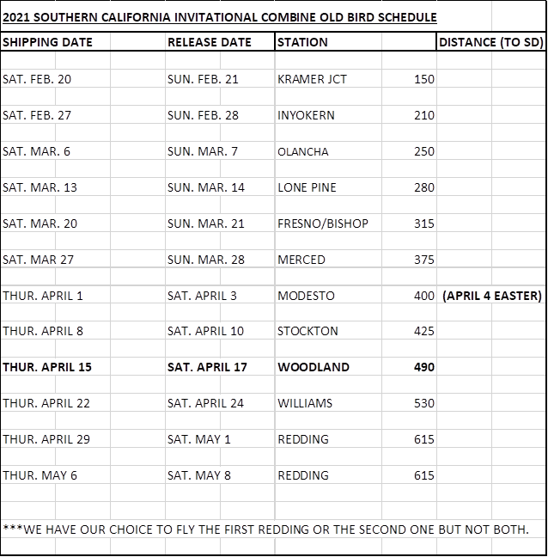

SHIPPING COST
Shipping Fee was determined at $300 per Adult Flyer for the Season. Per By Laws, can be paid in ½ increments.

ELECTION OF OFFICERS
A Motion was made by SD to accept all prior offices with exception to Race Secretary for the next two year offices. Seconded by PAL. Motion Passed.
Luis Gomez was nominated and voted in as Race Secretary.

President Luis Gomez
Vice President Bill Blankenship
Treasurer Carl Cardelli
Race Secretary Luis Gomez
Recording Secty Martha Stork

Meeting concluded approximately 12:00 pm

Respectively submitted by Martha Stork, Recording Secretary.

